**1st prototype design:**

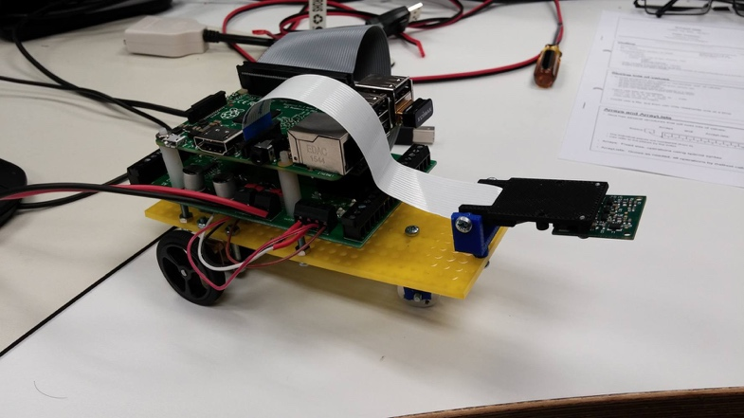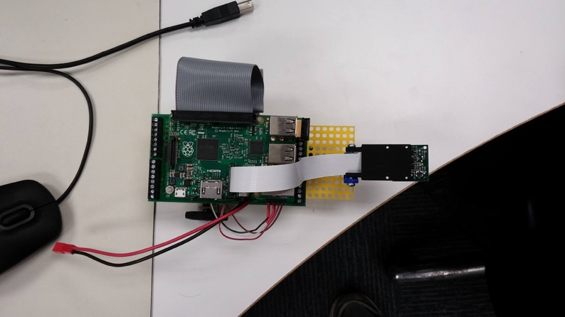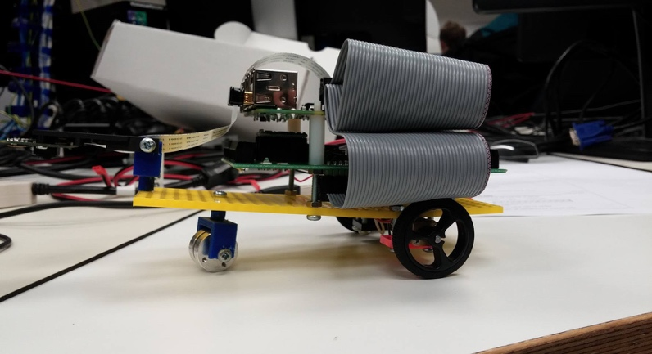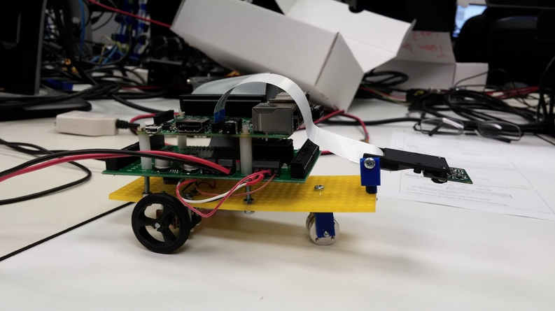

Pro’s:

1. The 1st prototype’s wheels are connected correctly and run.
2. Holds the RPI on vehicle.
3. The camera is connected correctly and is held in place.

Con’s: (including how to fix)

1. The board is bent due to pressure from the way we connected the RPI to it.  
   This will be fixed in the 2nd design by changing the way we connected the RPI to the board and having a new board.
2. The wheels are currently at the back of the vehicle which will make controlling the vehicle very hard due to the fact that the camera is taking a photo at the front (which is controlling the wheels). This means the camera and the wheels positions don’t directly correlate meaning we have to factor that effect in when coding.
3. Also, having the powered wheel at the front lets the vehicle turn from the front. This is better as it allows for a lot more control as the front non powered wheel is trailing the vehicle not directing it.
4. The Sensor isn’t held in place firmly so falls down.  
   For the 2nd design well will have made a way of holding it firmly while also being able to adjust it.
5. The front wheel isn’t doing much due to the bend in the board causing it to slide instead of roll along the ground.

A way to fix this is to have 4 similar wheels at each corner this will also fix any problems with balance of the small vehicle.